**Chocolate Distribution Problem Report**

**Simulation 1: Distribute a small set of chocolates among a few students, sort by weight, and search for a common chocolate type.**

**Objective:**

The first simulation aimed to distribute a set of five chocolates among two students, sort the chocolates by weight, and search for "Almond chocolate" within each student's collection.

**Setup:**

Chocolates: A total of 5 chocolates with varying types, weights, and prices were used.

Students: The chocolates were distributed among 2 students.

**Results:**

Distribution and Sorting:

Student 1 received Milk chocolate, White chocolate, and Almond chocolate, sorted by their weight from lightest to heaviest.

Student 2 received Dark chocolate and Peanut butter chocolate, sorted by their weight.

Search for "Almond chocolate":

Student 1: The search successfully found "Almond chocolate" within the collection, indicating that the search function accurately identifies chocolates based on type.

Student 2: The search did not find "Almond chocolate," and the program correctly returned a message indicating no match was found for 'Almond chocolate'.

**Screenshot**

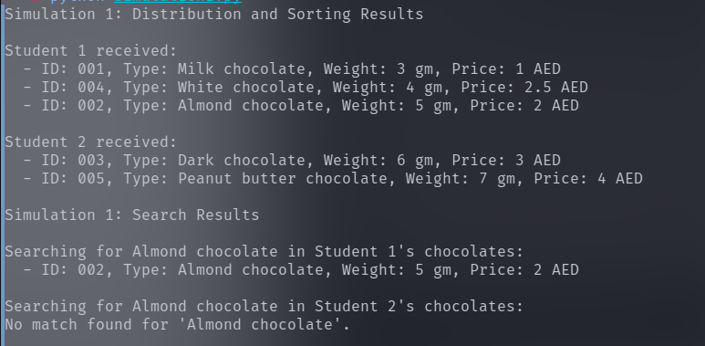

**Conclusion**

The first simulation demonstrated the program's ability to distribute a predefined list of chocolates among students in a fair manner, sort the chocolates based on weight, and accurately search for specific types of chocolates within each student's collection. The successful identification of "Almond chocolate" in Student 1's collection and the appropriate response when the chocolate was not found in Student 2's collection highlight the effectiveness of the sorting and searching functionalities.

**Simulation 2: Increase the number of chocolates and students, observe the distribution changes, perform sorting, and search for a rare chocolate type.**

**Objective:**

The objective was to distribute a larger variety and number of chocolates (10 in total) among 4 students, sort the chocolates by weight for each student, and search specifically for "Mint chocolate" to assess the distribution and search functionalities with a larger group and more variety.

**Setup:**

Chocolates: An expanded set of 10 chocolates, including new types to increase variety.

Students: Chocolates were distributed among 4 students.

Sort Criteria: Chocolates received by each student were sorted by weight.

Search Criteria: Searched for "Mint chocolate" within the students' collections.

**Results:**

Distribution and Sorting:

Chocolates were distributed among the 4 students, ensuring each received a portion of the variety, with the distribution and subsequent sorting by weight clearly reflecting the diverse range of chocolates.

Student 1 received White chocolate, Almond chocolate, and Berry chocolate.

Student 2 received Sugar-free chocolate, Peanut butter chocolate, and Mint chocolate.

Student 3 received Milk chocolate and Caramel chocolate.

Student 4 received Hazelnut chocolate and Dark chocolate.

Search for "Mint chocolate":

"Mint chocolate" was found within Student 2's collection, demonstrating the program's ability to accurately identify and report specific chocolates within the collections.

No matches were found for "Mint chocolate" within the collections of Students 1, 3, and 4, with the program appropriately indicating the absence of the chocolate searched.

**Screenshot**

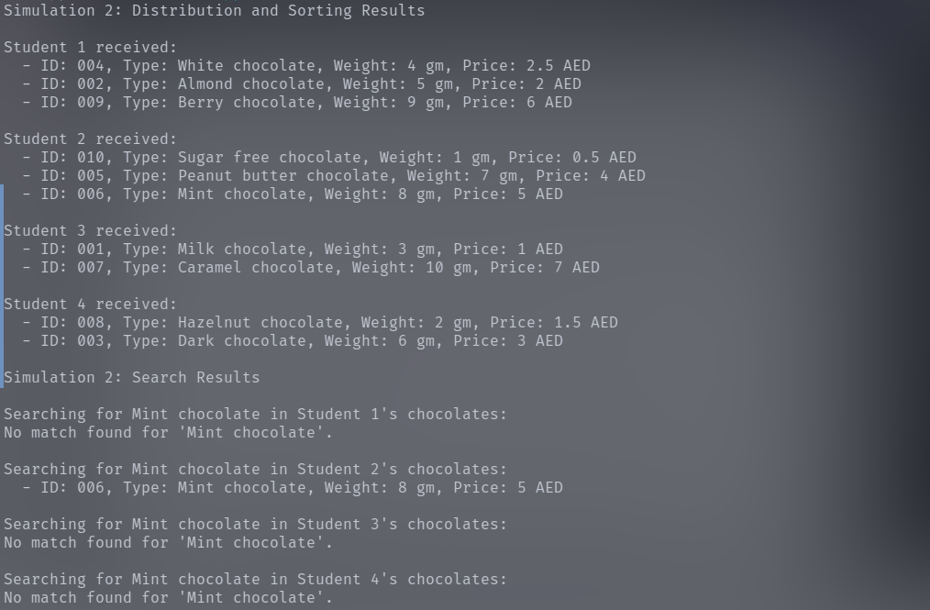

**Conclusion**

Simulation 2 successfully demonstrated the program's capability to handle a larger number of chocolates and students, accurately distribute and sort chocolates among students, and effectively search for specific chocolate types. The distribution ensured that every student received a fair share of the variety, and the sorting functionality allowed for an organized presentation based on weight. The search functionality was particularly tested with the specific query for "Mint chocolate," which was only present in one student's collection, showcasing the precision of the search mechanism.

**Simulation 3: Test with an even larger number of students than chocolates to see how distribution is handled when there are not enough chocolates for everyone.**

**Objective**

The third simulation aimed to examine the program's distribution logic when the number of students exceeds the available chocolates, with a focus on ensuring fairness in distribution. It also tested the sorting and searching functionalities in a scenario where some students did not receive any chocolates.

**Setup**

Chocolates: A total of 6 chocolates were used, creating a limited supply for distribution.

Students: 8 students participated, resulting in a scenario where there were more students than chocolates.

Sort Criteria: The chocolates received by each student were sorted by weight.

Search Criteria: The search focused on finding "Dark chocolate" within the distributed collections.

**Results**

Distribution and Sorting:

Chocolates were distributed to the first 6 students, with each student receiving one chocolate. Students 7 and 8 did not receive any chocolates, illustrating how the distribution logic handles scenarios of scarcity.

The chocolates received by each of the first 6 students were correctly sorted by weight, as per the setup.

Search for "Dark chocolate":

"Dark chocolate" was successfully found within Student 4's collection, indicating that the search function effectively identifies specific chocolates within the distributions.

The search results appropriately indicated the absence of "Dark chocolate" in the collections of the other students, including those who did not receive any chocolates.

**Screenshot**

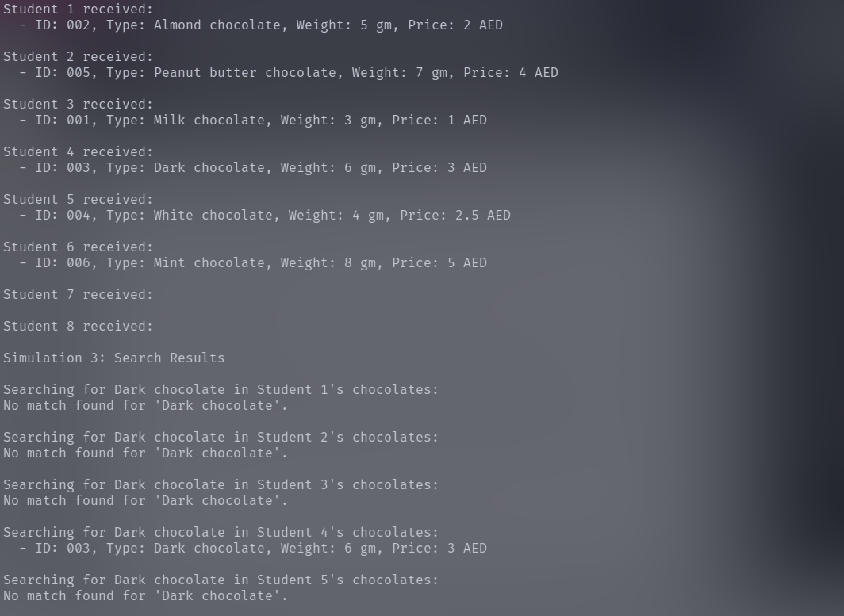

**Conclusion**

Simulation 3 demonstrated the program's ability to fairly distribute a limited number of chocolates among a larger group of students. The distribution ensured that chocolates were allocated to students on a first-come, first-served basis until the supply was exhausted. This simulation highlighted the program's capacity to handle scarcity and uneven distribution scenarios effectively.

The sorting functionality maintained its reliability by organizing the received chocolates by weight for those students who received them. The search functionality was robust, accurately identifying the presence or absence of a specific chocolate type across all students' collections, including indicating no matches found for students without chocolates.

**Simulation 4: Focus on the search functionality by searching for multiple chocolate types across different distributions.**

**Objective**

Simulation 4 was designed to thoroughly test the search functionality of the program by searching for various types of chocolates across different student distributions. The goal was to assess the program's ability to accurately identify both common and rare chocolate types within the collections.

**Setup**

Chocolates: A balanced assortment of 8 chocolates, including both common types like "Milk chocolate" and "Almond chocolate," and rarer types like "Berry chocolate" and "Hazelnut chocolate."

Students: The chocolates were distributed among 5 students, ensuring a diverse distribution pattern.

Searches: Searches were conducted for "Milk chocolate," "Almond chocolate," "Berry chocolate," and "Hazelnut chocolate," covering a range of commonality and rarity among the types.

**Results**

Search for "Milk chocolate": Successfully found in Student 3's collection, demonstrating the program's ability to locate common chocolate types.

Search for "Almond chocolate": Located in Student 1's collection, further confirming the search functionality's effectiveness.

Search for "Berry chocolate": Found in Student 2's collection, showcasing the program's capability to identify rarer chocolate types.

Search for "Hazelnut chocolate": Identified in Student 3's collection, indicating the program's comprehensive search capabilities across a variety of chocolate types.

**Screenshot**

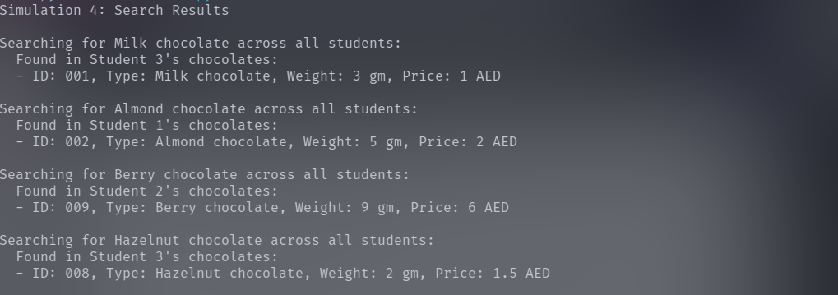

**Conclusion**

Simulation 4 validated the program's robust search functionality, demonstrating its effectiveness in accurately locating both common and rare chocolate types within various distributions. The program successfully identified the presence of specific chocolates within the students' collections, efficiently handling searches across a balanced mix of chocolate types.